класс__7__________________

ф________________________

и_________________________

**6.2 Моделирование.**

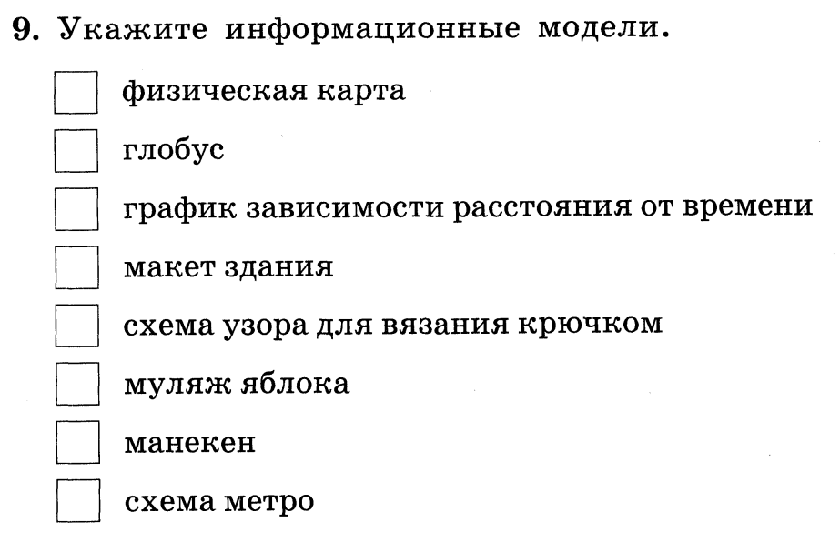

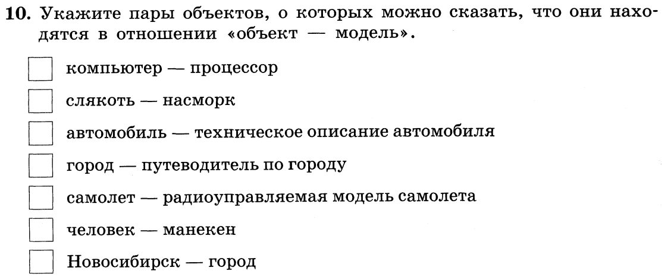

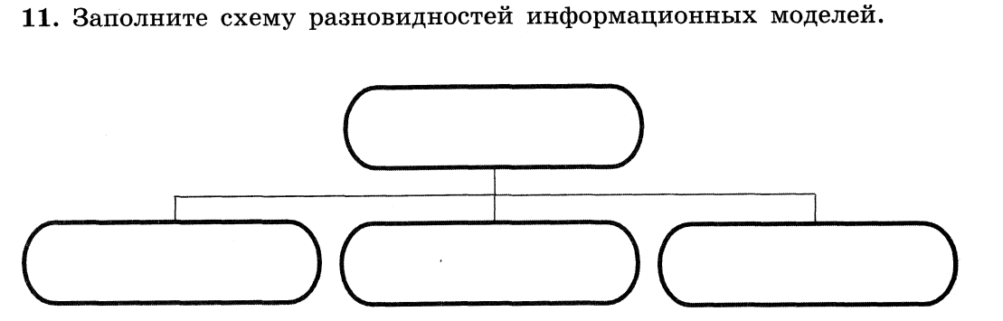

**12. Приведите примеры:**

а) образной информационной модели ____________________________

____________________________________________________________

_________________________________________________________________

_________________________________________________________________

б) знаковой информационной модели ___________________________

____________________________________________________________

_________________________________________________________________

_________________________________________________________________

в) смешанной информационной модели _________________________

____________________________________________________________

_________________________________________________________________

_________________________________________________________________

